Assessment Item 4:

User Acceptance Testing

Name: Jean Claude Jino Rousseau

Student ID: 11590309

Lecture: Friday 9.00 am - 12.00 pm

Due Date: 07.10.2016

Lecturer: Dr. Recep Ulusoy

Number of words: 1074

Table of Contents

Introduction 3

Replication 3

Test Case ID: Test Case Name: 3

# Introduction

In software development, **user acceptance testing** (**UAT**) - also called beta testing, application testing, and end user testing - is a phase of software development in which the software is tested in the "real world" by the intended audience.

This report will talk about the last phase of the software testing process. During that phase, actual software users test the software to make sure it can handle required tasks in real-world scenarios, according to specifications.

The UAT is the final and critical procedure that must occur before the improved software is rolled out to the public

# Replication

The replication of each bug that I wrote in my ‘Debugging’ report are provided below.

## Test Case ID: B_1 Test Case Name: Balance after a bet is made

|  |  |
| --- | --- |
| **Test Name** | Bug 1 (Balance after a bet is made) |
| **Test Description** | The balance after the player wins should be the legit amount that should be paid according to the game rule |
| **Pre-condition** | * The game is started * It displays the balance the player has * The bet and the limit are displayed * Player is older than 18-year-old |
| **Post-condition** | * The dice is rolled and the result is displayed * A message is displayed about whether the user has won or lost * The updated balance is displayed and correct |

|  |  |  |  |
| --- | --- | --- | --- |
| **Steps#** | **Test Action** | **Expected Results** | **Pass/Fail** |
| 1 | Launch the ‘CrownAndAnchorGame | The game starts | Pass |
| 2 | Game asks for a name | Player enters name | Pass |
| 3 | Game asks for the balance the player has | Player enters balance amount | Pass |
| 4 | Game asks for player’s age | Player enters age | Pass |
| 5 | Dice are rolled | Game runs until the number of games expected, expires or player has no more money | Pass |
| 6 | Balance is displayed each time the dice are rolled | Balance is right | Pass |

Step 6 would have failed if the player had won a game and the balance does not reflect those three components: the amount that has been bet, the balance while the dice are rolled, and the win if the player wins

|  |  |  |  |  |
| --- | --- | --- | --- | --- |
| **Turn** | 1 | 2 | 3 | 4 |
| **Bet on** | Heart | Crown | Anchor | Anchor |
| **Start balance** | 100 | 105 | 110 | 105 |
| **Rolled result** | HEART, CROWN, CLUB | | | |
| **Balance** | 105 | 110 | 105 | 100 |

The screenshot below demonstrate that the bug has been fixed.

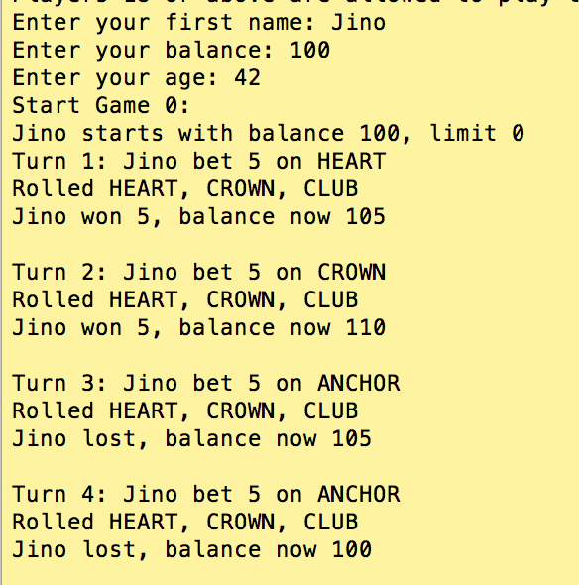

## Test Case ID: Test Case Name:

|  |  |  |
| --- | --- | --- |
| **Test Name** |  |  |
| **Test Description** |  |  |
| **Pre-condition** |  |  |
| **Post-condition** |  |  |

|  |  |  |  |
| --- | --- | --- | --- |
| **Steps#** | **Test Action** | **Expected Results** | **Pass/Fail** |
|  |  |  |  |

|  |  |  |  |  |  |
| --- | --- | --- | --- | --- | --- |
| **Turn** | 1 | 2 | 3 | 4 | 5 |
| **Symbol** |  |  |  |  |  |
| **Wage** |  |  |  |  |  |